**CHANDIGARH UNIVERSITY**

**UNIVERSITY INSTITUTE OF ENGINEERING**

**DEPARTMENT OF COMPUTER SCIENCE & ENGINEERING**



|  |  |
| --- | --- |
| **Submitted By: SANSKAR AGRAWAL Submitted To: Er. RAHUL BHANDARI** | |
| **Subject Name** | Competitive Coding |
| **Subject Code** | 20CSP-314 |
| **Branch** | CSE |
| **Semester** | 5th |

**LAB INDEX**

**NAME**: SANSKAR AGRAWAL **SUBJECT NAME:** Competitive Coding Lab

**UID:** 20BCS5914 **SUBJECT CODE:** 20CSP-314

**SECTION:**20BCS_WM_617_B

|  |  |  |  |  |  |  |  |
| --- | --- | --- | --- | --- | --- | --- | --- |
| **Sr.**  **No** | **Program** | **Date** | **Evaluation** | | | | **Sign** |
| **LW**  **(12)** | **VV**  **(8)** | **FW**  **(10)** | **Total**  **(30)** |
|  |  |  |  |  |  |  |  |
|  |  |  |  |  |  |  |  |
|  |  |  |  |  |  |  |  |
|  |  |  |  |  |  |  |  |
|  |  |  |  |  |  |  |  |
|  |  |  |  |  |  |  |  |

**Experiment – 1**

Student Name: SANSKAR AGRAWAL UID: 20BCS5914

Branch: CSE Section/Group: 806/B

Semester: 5th Sem Date of Performance: 09 Aug,2022

Subject Name: Competitive Coding Subject Code: 20CSP-314

# Problem Statement 1.1

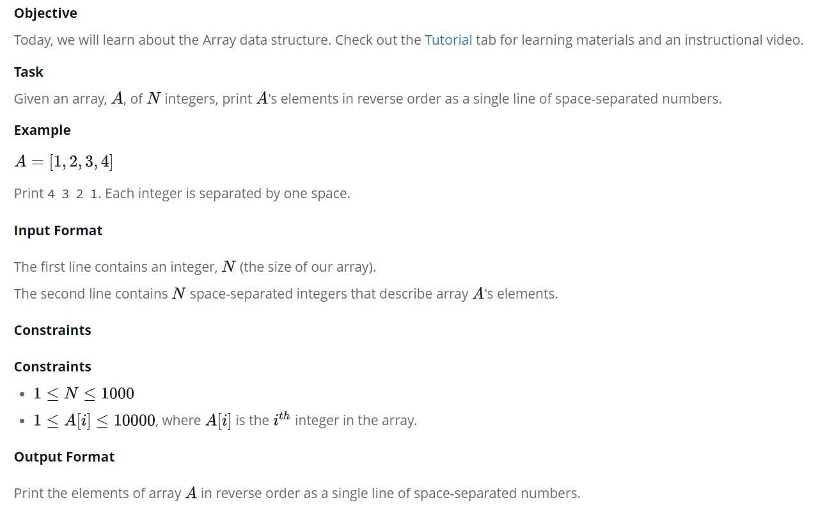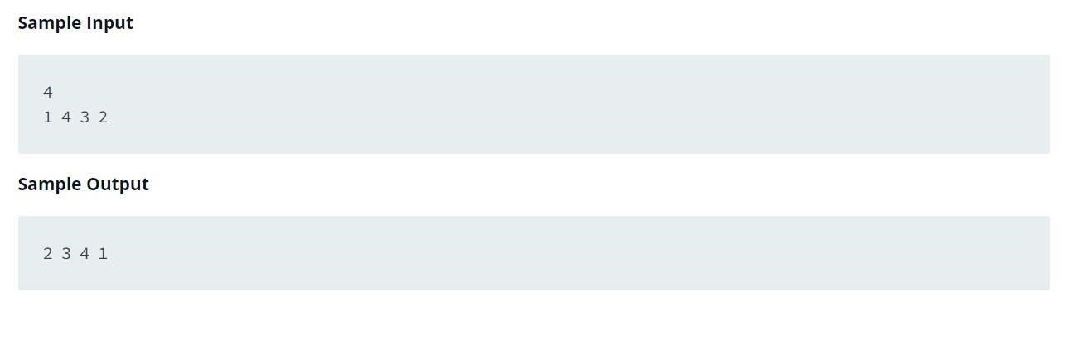

**Solution:**

#include <bits/stdc++.h>

using namespace std;

void reverse(int *arr,int n,int i,int j){

//base case : if(i>j){ return;

}

// processing int temp = arr[i]; arr[i]=arr[j]; arr[j]=temp; i++; j--;

reverse(arr,n,i,j);

} int main() { int arr[10000]; int n; cin>>n; for(int i=0;i<n;i++){ cin>>arr[i];

} int start = 0; int end = n -1;

reverse(arr,n,start,end);

for(int i=0;i<n;i++){ cout<<arr[i]<<" ";

} cout<<endl;

}

**Output:**

